DIF-M (Do it For Me): A deep dive into Knowledge Distillation and DistilBERT

Ahmed Akib Jawad Karim
Department of Electrical and Computer Science
North South University
15/B, Bashundhara R/A, Dhaka-1229
anjana.tameem@northsouth.edu

Anjana Tameem
Department of Electrical and Computer Science
North South University
15/B, Bashundhara R/A, Dhaka-1229
anjana.tameem@northsouth.edu

Kazi Hafiz Md. Asada
Department of Electrical and Computer Science
North South University
15/B, Bashundhara R/A, Dhaka-1229
ahanaf.tahmid@northsouth.edu

Abstract—

Keywords— Knowledge Distillation, DistilBERT, Natural Language Processing, Deep Learning, Graph Based Distillation.

Introduction

According to Cambridge dictionary, distillation means the action of reducing something to its main meaning or most important parts [1]. In that way knowledge distillation means the action of reducing knowledge to its most important parts. But what that means in Deep learning or in NLP? The process of transferring knowledge from a huge unmanageable model or group of models to a single smaller model that can be effectively implemented under real-world limitations is referred to as knowledge distillation. In simple words, knowledge distillation is the process of moving knowledge from a big model to a smaller one in deep learning.

Transfer Learning techniques to Natural Language Processing (NLP) have grown in popularity over the last two years, with large-scale pre-trained language models being a standard tool in many NLP applications [2]. While these models result in considerable improvements, they frequently include hundreds of millions of parameters, and recent research on pre-trained models shows that training even bigger models results in improved performance on downstream tasks. The difficulty of installing big deep neural network models is particularly relevant for edge devices with limited memory and processing capabilities.

To address this issue, a model compression approach was initially presented in order to transfer information from a big model into training a smaller model without substantial performance loss. Because smaller models are less expensive to analyse, they may be run on less powerful hardware. Hinton and colleagues [3] defined this method of learning a tiny model from a bigger model as a "Knowledge Distillation" framework. In this research, we demonstrate that identical performance on various downstream-tasks can be achieved with significantly smaller language models pre-trained using knowledge distillation, resulting in models that are lighter and quicker at inference time while simultaneously needing a less computational training budget.

A. Basic Framework of Knowledge Distillation:
The main principle behind Knowledge Distillation is to generalize data by making a smaller, less complicated model replicate a larger, more complex one. If the complex model generalizes well, for example, because it is the average of several models, a small model trained to generalize in the same way (via Knowledge Distillation) will typically perform much better on test data than the same small model trained in the traditional Deep Learning way on the same training set.
The Knowledge Distillation models named Teacher and Student models are two neural network methodologies.

i. Teacher model:
To construct a bigger burdensome model, an ensemble of individually trained models or a single extremely large model trained with a very strong regularizer such as dropout can be utilized. This bigger model is the first one to be trained.

ii. Student model:
A more compact form that will rely on the distilled expertise of the Teacher Network. It uses a technique known as "distillation" to transmit knowledge from the big model to the smaller Student model. The student model is better suited for deployment since it is less computationally expensive than the Teacher model while retaining the same or superior accuracy.

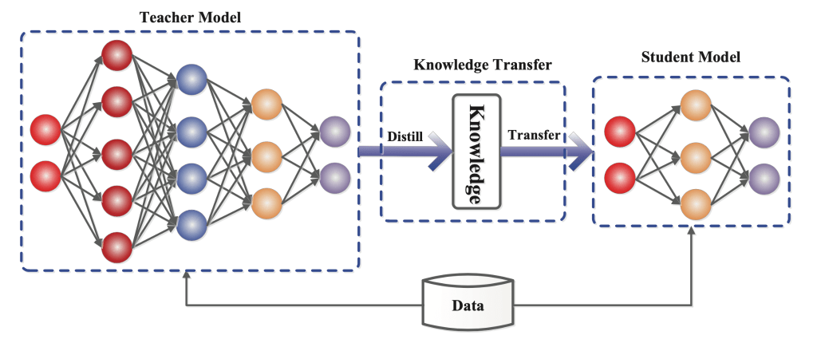
Figure: The generic teacher-student framework for knowledge distillation. [4]
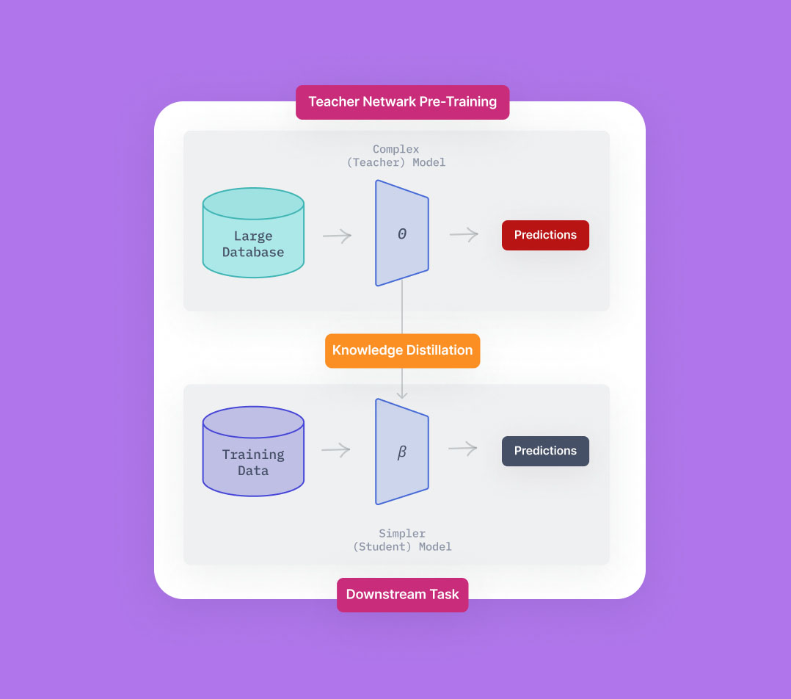
Figure: High-level view of Knowledge Distillation [5]

Class probabilities are commonly produced by neural networks using a "softmax" output layer that translates the logit, z_{i}, generated for each class into a probability, p_{i}, by comparing z_{i} to the other logits. Following Hinton et al. [2015] we used a softmax-temperature:

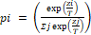

Where zi is the model score for the class I and T is the typical temperature of one. A larger value for T results in a softer probability distribution across classes. A larger value for T results in a softer probability distribution across classes. The information is transferred to the distilled model in the simplest form by training it on a transfer set and using a soft target distribution for each instance in the transfer set formed by utilizing the ponderous model with a high temperature in its softmax. When training the distilled model, the same high temperature is employed, but once learned, it utilizes a temperature of 1.
Knowledge types, distillation techniques and the teacher-student architectures of knowledge distillation play the crucial role in the student learning. However, different categories of knowledge and their distillation techniques for knowledge distillation will be discussed in other sections.

Related Works:

Introduction:

Traditional language models, such as BERT, are time and resource intensive, with complicated and unwieldy structures. In the discipline of natural language processing (NLP), knowledge distillation is intensively investigated in order to develop lightweight, efficient, and effective language models. For resolving the diverse NLP challenges, more and more knowledge distillation approaches are developed. BERT has received interest in natural language comprehension as a multilingual representation model (Devlin et al., 2019), but it is also a burdensome deep model that is difficult to apply. To solve this issue, numerous lightweight variants of BERT (referred to as BERT model compression) based on knowledge distillation have been proposed.

Research in Knowledge Distillation

In (Sanh et al., 2019) [5], a minimalist student model named DistilBERT is created and taught on a range of NLP tasks using the same general framework as BERT. DistilBERT is a pre-trained general-purpose version of BERT that is 40% smaller and 60% quicker while retaining 97% of the language comprehension capabilities. The general architecture is the same as in BERT. The pooler and token-type embeddings are deleted, and the number of layers is decreased by a factor of two. DistilBERT is distilled in extremely large batches (up to 4K instances per batch) using dynamic masking and without the next sentence prediction target.
A task-specific knowledge distillation was presented from the BERT teacher model into a bidirectional long short-term memory network (BiLSTM) by Tang et al. (2019) [6]. TinyBERT is a two-stage transformer knowledge distillation suggested by Jiao et al. (2020) [7]. It distils general-domain and task-specific information.
Sun et al. (2019) [8] suggested patient knowledge distillation for BERT model compression (BERT-PKD), that can be utilized for natural language inference, similarity matching, sentiment classification, and machine reading comprehension. The feature representations of the [CLS] token from the hint layers of the teacher is transferred to the student in the patient KD method.
Yang et al. [2019] [9] use multi-task learning to regularize the distillation by combining the expertise of an ensemble of teachers. The researchers use Multi-Task Knowledge Distillation to extract a condensed question answering model from a vast number of question-answering models. Knowledge distillation transfers knowledge among multilingual word embeddings for bilingual dictionary induction in multilingual representations (Nakashole and Flauger, 2017) [10].

Observations from previous researches

The following are some observations regarding knowledge distillation for natural language processing:

Knowledge distillation creates compact language deep models that are effective and efficient. The large-capacity teacher model can transmit the rich information from a wide range of different types of language data to train a tiny student model, allowing the student to do multiple language tasks quickly and effectively. Because information from multilingual models may be transmitted and shared by each other, teacher-student knowledge transfer can readily and successfully tackle various multilingual challenges. Deep language models can successfully transfer sequence information from big networks to tiny networks.

What we want to do:

We are working with DistilBERT, which is a pre-trained general-purpose version of BERT that is 40% smaller and 60% quicker while retaining 97% of the language comprehension capabilities. If with our research we could make DistilBERT even smaller and quicker than it already is, on low resources, It would be a great addition to the vast research works done on knowledge distillation and NLP. We will also explore try to explore Graph based distillation as there are not many works on this topic. Graph-based distillation captures intra-data relationships using graphs instead of individual instance knowledge from the teacher to the student. In graph-based distillation, each vertex of the graph represents a self-supervised teacher which may be based on response-based or feature-based knowledge like logits and feature maps respectively. So, we will try to deep dive into that.

References
- Cambridge Dictionary. Knowledge distillation. Cambridge University Press, https://dictionary.cambridge.org/dictionary/english/distillation
- Jacob Devlin, Ming-Wei Chang, Kenton Lee, and Kristina Toutanova. Bert: Pre-training of deep bidirectional transformers for language understanding. In NAACL-HLT, 2018
- Hinton G, Vinyals O, Dean J. Distilling the Knowledge in a Neural Network. NIPS Deep Learning and Representation Learning Workshop, 2015. https://arxiv.org/abs/1503.02531
- Jianping Gou, Baosheng Yu, Stephen J. Maybank, Dacheng Tao. Knowledge Distillation: A Survey. International Journal of Computer Vision, 2021. https://arxiv.org/abs/2006.05525v7
- Rohit Kundu, Knowledge Distillation: Principles & Algorithms [+Applications], 2022. Knowledge Distillation: Principles & Algorithms [+Applications] (v7labs.com)
- Sanh, V., Debut, L., Chaumond, J. & Wolf, T. (2019). Distilbert, a distilled version of bert: smaller, faster, cheaper and lighter. arXiv preprint arXiv:1910.01108.
- Tang, R., Lu, Y., Liu, L., Mou, L., Vechtomova, O. & Lin, J. (2019). Distilling task-specific knowledge from bert into simple neural networks. arXiv preprint arXiv:1903.12136.
- Jiao, X., Yin, Y., Shang, L., Jiang, X., Chen, X., Li, L. & et al. (2020). Tinybert: Distilling bert for natural language understanding. In: EMNLP
- Sun, S., Cheng, Y., Gan, Z. & Liu, J. (2019). Patient knowledge distillation for bert model compression. In: NEMNLP-IJCNLP.
- Ze Yang, Linjun Shou, Ming Gong, Wutao Lin, and Daxin Jiang. Model compression with multi-task knowledge distillation for web-scale question answering system. ArXiv, abs/1904.09636, 2019.
- Nakashole, N. & Flauger, R. (2017). Knowledge distillation for bilingual dictionary induction. In: EMNLP.

